# An Analysis of Oil / Oil Products Relationships in Different Markets

Promo Anene1, Ruphin Aganze2, Tarun Kumar3

*Master of Science in financial Engineering, World Quant University*

*1*[*promo.anene@yahoo.com*](mailto:promo.anene@yahoo.com)*, 2*[*jfrayruphin@yahoo.fr*](mailto:jfrayruphin@yahoo.fr)*, 3*[*bing.tome@yahoo.co.in*](mailto:bing.tome@yahoo.co.in)

November 219

# *Abstract*

Crude oil is a key commodity in world economy. It finds strategic importance and varied uses in many diverse applications, industrial and domestic. These include transportation, industrial power, home energy and everyday products such as plastics, drugs etc. In combination with other chemicals, oil forms the base of over thousands of products.

Crude oil is also a highly volatile asset that is subject to wide price swings. In the world of financial engineering, it is not uncommon to find portfolios comprising assets that are directly or indirectly linked to crude oil or its products.

In order to maximize gains from oil-related assets, it is necessary to understand its price drivers. In this regard, it is noteworthy that crude oil prices are driven primarily by the price of its refined products. These include gasoline, diesel, jet fuel, naphtha, fuel oils etc. This research project investigates the price relationship between crude oil and its refined products for different crude blends defined by geographical locations (WTI, Brent and Bonny Light). Statistical analysis is conducted on 20-year monthly price data. The analysis primarily comprises time series analysis of spreads and tests for mean reversion and correlation across different time periods.

We find that indeed, a price relationship exists between crude oil and its products to varying degrees for the blends tested (WTI, Brent and Bonny Light). We hope that this research work can enable predictions of short-term price changes for oil and product commodities. We also expect that the relationship established in this research work can be leveraged in portfolio risk management and portfolio diversification.

**Keywords:** crude oil, refined product, West Texas Intermediate, WTI, Brent, Bonny Light, equilibrium modelling.

**1. Introduction**

Oil forms the lifeblood of the world’s economy. Oil products underpin modern society and are used in a wide range of industrial and domestic application. These include transport fuels, industry power, home heating and manufacture of everyday products such as plastics, medicines, detergents, paints etc. As a result, the prices of refined oil products play a key role in stabilising world economy and social order.

Oil prices are subject to wide price swings due to the forces of demand and supply i.e. it has experienced high prices occasioned by periods of high demand, but also depressed prices due to oversupply and low demand. These so-called price cycles tend to last several years, depending on variables such as oil demand, volume of oil drilled, processed and sold by major producers, including integrated oil companies (IOCs), geopolitical factors etc.

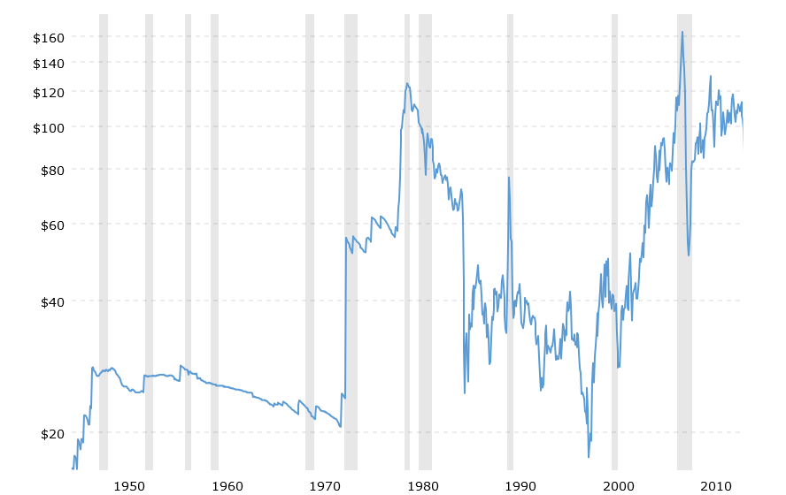

**Figure 1. Wide price swings in oil prices**

*Source : https://www.macrotrends.net/1369/crude-oil-price-history-chart*

Notwithstanding the price swings, crude oil is a widely traded and important commodity in the world. As earlier noted, it is a key underpinning factor in many economies. There is a well-established and highly competitive international market for this commodity. It is a sophisticated financial product with high uncertainty and volatility.

The key factor that affects the price of oil products such as gasoline is the corresponding crude oil price. An effective understanding of the relationship between crude oil prices and their corresponding refined products, can enable predictions of short-term price changes. Also, and very importantly, the relationship between crude oil and refined products can be leveraged in portfolio risk management and portfolio diversification.

Portfolio diversification is a risk management strategy where a variety of assets are combined in order to reduce overall risk of the investment portfolio. Effective asset combination in this regard requires that the asset mix are not highly inter-correlated. Otherwise, where asset covariance is high, portfolio risk reduction due to diversification is reduced. It is thus important to investigate the relationship between crude and refined products to enable portfolio risk management especially with price variability for a portfolio of crude and refined products, such as for integrated oil companies which both produce and refine crude oil.

This project will assess price relationships for crude oil and their refined product (gasoline et al) (in three regions as follows:

1. the United States – US crudes vs. Western Texas Intermediate (WTI)
2. Nigeria – Bonny Light crude vs. Nigerian Petrol prices
3. North Sea crudes – Brent Blend vs. gasoline prices

The project will enable enhanced understanding of crude oil/refined products relationships and thus enhance effective portfolio risk management for crude and refined products portfolio mix, as well as asset price prediction for effective trading strategy.

The project objectives include:

1. Perform Exploratory Data Analysis on price data for crudes and products
2. Compare key statistical metrics across the different markets
3. Provide insights and possible economic explanations for the observed differences

**2. Theoretical Framework**

**2.1. Introduction**

There have previous research efforts into investigating the relationships between crude oil prices and their refined products counterparts. These researches have been mostly of a broad market review nature. One key research in this area is the work by Gjolberg and Johnsen (2003, *Risk management in the oil industry: Can information on long-run equilibrium prices be utilized*) [1,2] in which it is established that a long-term relationship does exist between crude and refined products.

There have also been other studies and efforts to model oil prices. The work by Fischer D., Gately D., Kyle J. (1975) [3] is one of the early research studies conducted on oil price modelling. The studies by Bacon and Kojima (2006 and 2008) [4,5] was with an emphasis on statistics and economics. Many other studies, while reviewing oil price fluctuations do not specifically focus in-depth on the price relationship between crude oil and their corresponding refined products per blend.

Many studies also find that the transmission of positive and negative changes in crude prices to the refined products (gasoline et al) is asymmetric [6-13]. Specifically, responses to price increases are much quicker than for price decreases. This is more evident in the US market than for the Euro region where mixed results have been noted.

In developing countries, refined product prices are more subject to price control constraints. A review carried out by the International Monetary Fund (IMF) found that out of 48 developing economies considered, only 16 countries have implemented a market-based pricing system for refined petroleum [14]. In Nigeria, this is effected through a Federal Government fuel subsidy programme.

This literature review analyses the main work carried out by Gjolberg and Johnsen (2003, Risk management in the oil industry: Can information on long-run equilibrium prices be utilized) [1] and establishes the additional contributions this research project will make to the already established body of knowledge in this regard.

**2.2. Review of Existing Literature**

This literature review will focus on the work by Gjolberg and Johnsen (2003, *Risk management in the oil industry: Can information on long-run equilibrium prices be utilized*) [1]. The work investigated price volatility and correlations between crude oil price and refined products (Premium gasoline, naphtha, jet fuel, gas oil light fuel oil and heavy fuel oil) between the periods from January 1992 to August 1998.

Data Sources

The data set was sourced from Platt’s. Monthly observations were used by picking the prices recorded on the 15th of each month or the closest day of business.

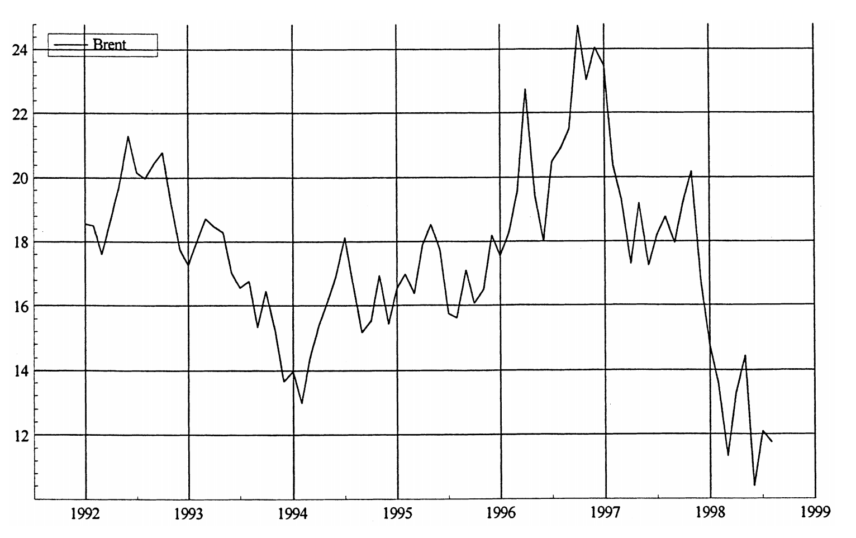

**Figure 2. Crude Brent price US$ Ž . rbbl, January 1992] August 1998.**

The data shows the wide variability of Brent prices within the period of study. High price volatility is observed, including a low of US$13/bbl in 1994, a high of above US$24/bbl in 1996 and a crash to US$11/bbl in 1998.

Exploratory Analysis and Econometric Results

Table 1 below shows the coefficients of price variations and the annualized standard deviation of monthly price changes (%). As observed, the coefficients of variation do not differ much between crude oil (16.1) and the products – except for heavy fuel oil (21.9).

**Table 1 – Price volatility, 1992 – 1998**

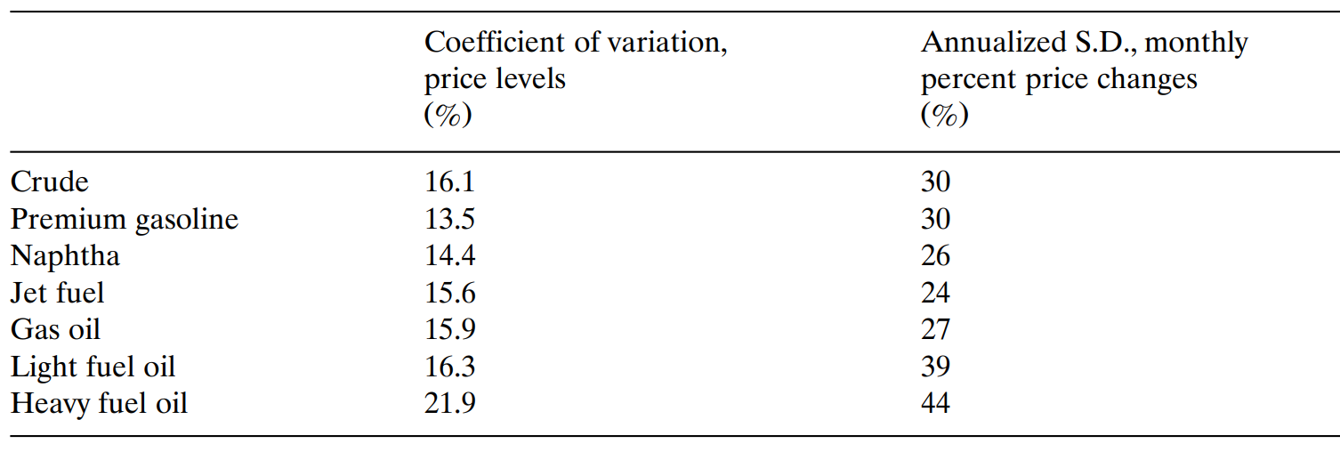

The correlations for price level and price changes are shown below in Table 2 and Table 3 respectively:

**Table 2 - Price level correlations, 1992 – 1998 (monthly observations)**

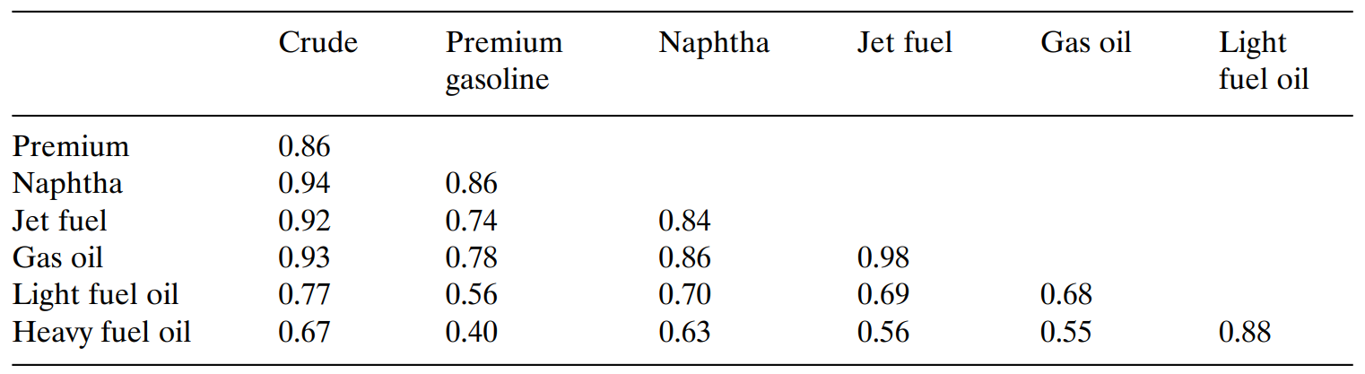

**Table 3 - Price change correlations, 1992 – 1998 (monthly observations)**

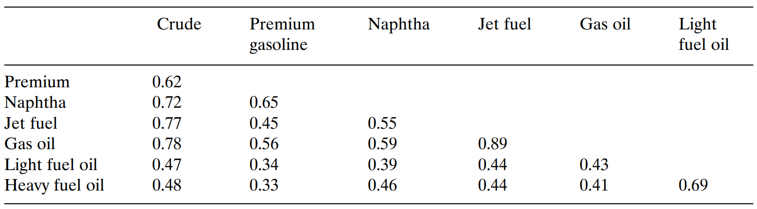

As seen above, the co-changes between the price level for crude oil and the refined products is quite high – 86% and 93% for premium gasoline and gas oil. The figures are slightly lower for LFO and HFO at 77% and 67% respectively. Similarly, there is relatively high correlation between crude and products price changes. The correlations between crude and the heavier fuel oils are lower, as with the correlations between lighter products and the heavier ones. As earlier noted, these correlations represent valuable insight for portfolio diversification and risk management.

The main statistics from Ordinary Least Squares (OLS) estimation are shown below.

**Table 4 – Summary of estimation results – OLS**

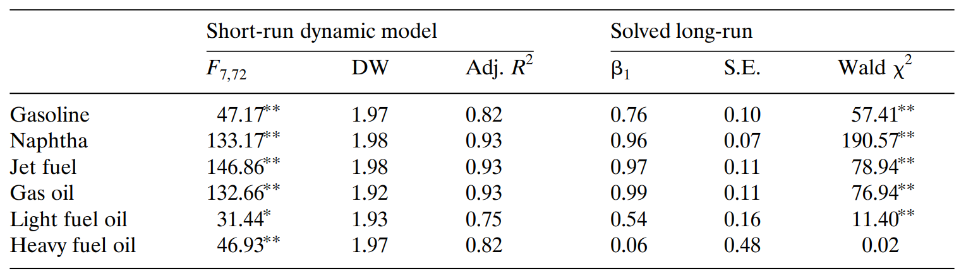

In Table 4 above, the F-values are all significant at 1% level. The Durbin-Watson statistics which measures autocorrelation are all close to 2.0 i.e. very low positive autocorrelation. The explained variance, as indicated by Adj. R2, range from 75% for LFO to 93% for naphtha, jet fuel and gas oil.

The research concludes by establishing that there is indeed a long-run spot price relationship between crude and refined products. In effect, for all refined products, possibly excluding heavy fuel oil, product prices are co-integrated with the crude price[15].

**2.3. Strengths and Opportunities of Current Research**

Current research has built on previous research works. To illustrate, previous research studies have tended to focus on the convergence of spot and future prices towards delivery (e.g. Ng and Pirrong, 1996) [16] or the price discovery roles of futures vs. spot prices (e.g. Quan, 1992; Schwarz and Szakmary, 1994) [17]. The work by O. Gjolberg and T. Johnsen (1999) instead drew attention “to the long-run spot price relationship between crude and products.”

Quantitative econometric tools (OLS et al) are deployed. This ensures that modern statistical methods of analysis are leveraged in the research studies.

A wide array of refined products has been used in current studies including premium gasoline, naphtha, jet fuel, gas oil, light fuel oil and heavy fuel oil.

**2.4. Weaknesses and Threats to Current Research**

Current studies are for relatively short periods of time. For example, the work by O. Gjolberg and T. Johnsen (1999) used a 7-year period from 1992 to 1998. In comparison, our research work is proposed to cover a 20-year period. This makes for a more holistic research study.

Research studies on the subject also lack recency. As far as we know, there is a lack of established studies conducted within the last 5 years, hence the need to update existing findings.

Current research works have not drawn clear delineation for geographical regions to account for focused relationship between crude in specific regions or countries and their corresponding products. Our proposed research study will improve on this aspect by clearly ring-fencing the studies with respect to three specific crude specimens per geographical specifications – WTI (United States), Brent (Europe) and Bonny Light (Nigeria).

**2.5. Further Justification for Research Studies**

As stated above, the proposed research project will attempt to bridge gaps in current research works, including extended period covered (20 years instead of 7), make more recent, delineate per geographical location. In addition, deeper analysis will be conducted e.g. ARIMA models instead of simplified OLS. The impact of socio-political factors will also be considered where applicable.

**2.6 Potential Challenges to be Encountered in Research Study**

One key aspect that is expected to pose a challenge in the research project is with obtaining reliable and complete data for the different crude oil blends and their associated products. It is necessary that data obtained should be complete, accurate and in the right format for ease of analysis. This is especially so with Bonny Light from Nigeria.

Another potential challenge is with error correction in the data. Oil price data is highly sensitive to external vagaries, many of which can be mere very transient e.g. political developments and social anxieties. It will thus be necessary to pay close attention to potential false calls, outliers etc. that can have disproportionate distortions on the price relationships.

**3. Methodology**

**3.1 Process Steps**

Data Collection

Contemporary data will be collected from relevant sources (paid and unpaid) for price data of crude oil and its products for the stated geographical regions – United States, Europe and Nigeria. Further details on the data sources are shown below. It is planned that the research period will cover a 20-year window spanning 1999 to 2019. Monthly data will be used across board. However, where it is necessary to inspect more granular data (weekly or daily) or to expand the time period covered, in order to gain more insight in the research, additional data will be sourced accordingly. The first 17-year data (1999 to 2016) will be used for training the price model while the last 3-year data will be used for testing the model.

Data Clean-up

It is not unusual for data from internet sources to contain missing observations and bad data. This is especially so with free (unpaid) data sources. It is planned that all data sources collected for this research project will be inspected and cleaned up accordingly. These measures will include getting rid of extra spaces, resolving blank cells, correcting data formats (e.g. Excel to CSV, numbers stored as text), removing duplicates, resolving data input errors, correcting letter cases and spellchecking.

Exploratory Data Analysis

This will involve presenting the data visually as time series plots and conducting Q-Q (Quantile-Quantile) analysis. The time series plot will show average monthly data spanning over 20 years for the various price data for crude oil of crude oil and refined products in the three geographical locations selected.

A Q-Q analysis will show plot one quantile of data for the crude oil price in each geographical location against its corresponding refined product. This is powerful approach at showing goodness of fit as an initial preliminary analysis for the oil price data.

Statistical Analysis

Following on from the above, a more detailed statistical analysis will be conducted on the price data across the different markets as below. The similarities and differences will be assessed accordingly.

1. Variance
2. Skew
3. Kurtosis
4. Covariance
5. ARIMA

Model Testing

As noted, statistical modelling will be conducted using the first 17years of price data (1999 to 2016) in order to establish valid mathematical relationships i.e. price model between crude and refined products. Thereafter, the model will be used to predict oil prices for the last 3-year data from 2016 to 2019. The model’s accuracy and reliability will be assessed accordingly.

Report Writing

The insight gained from the statistical analysis conducted will be articulated in a research report detailing the findings and discussing possible economic explanations for the differences observed.

**3.2 Data Sources**

Monthly price data shall be obtained for the last 20 years i.e. 1990 till date from relevant sources. The sources of data for the research project shall include the following, without limitation;

1. FRED Economic Data (https://fred.stlouisfed.org/)
   1. [Crude Oil Prices: West Texas Intermediate (WTI) - Cushing, Oklahoma](https://fred.stlouisfed.org/series/DCOILWTICO)
   2. [Global price of WTI Crude](https://fred.stlouisfed.org/series/POILWTIUSDM)
   3. [Crude Oil Prices: Brent - Europe](https://fred.stlouisfed.org/series/DCOILBRENTEU)
   4. [Global price of Brent Crude](https://fred.stlouisfed.org/series/POILBREUSDM)
2. US Energy Information Administration (https://www.eia.gov/)
   1. Crude Oil - WTI - Cushing, Oklahoma
   2. Crude Oil – Brent Europe
   3. Conventional Gasoline - New York Harbor, Regular
   4. Conventional Gasoline - U.S. Gulf Coast, Regular
   5. Ultra-Low-Sulfur No. 2 Diesel Fuel - New York Harbor
   6. Ultra-Low-Sulfur No. 2 Diesel Fuel - U.S. Gulf Coast
   7. Ultra-Low-Sulfur No. 2 Diesel Fuel – Los Angeles
3. Central Bank of Nigeria (<https://www.cbn.gov.ng/>)
   1. Crude Oil Price – Bonny Light
   2. Refined Petroleum Price – Nigeria
4. S&P Global Platts Prices (https://www.spglobal.com/platts/en/)
   1. Platts Market Data – Oil
   2. Platts European Marketscan
   3. Platts North American Crude and Products Scan
   4. Platts World Refinery Database

**3.3 Technology and Deliverables**

It is planned that Python programming language will be used to conduct the statistical analysis and visualization while academic-style paper will be written in Latex.

**References**

1. Gjolberg, O.; Johnsen, T. Risk management in the oil industry: Can information on long-run equilibrium prices be utilized? Energy Econ. 1999, 21, 517–527.
2. Asche, F.; Gjolberg, O.; Volker, T. Price relationships in the petroleum market: An analysis of crude oil and refined product prices. Energy Econ. 2003, 25, 289–301.
3. Fischer D., Gately D., Kyle J. (1975) “The Prospects for OPEC: A Critical Survey of Models of the World Oil Market.” Journal of Development Economics, 2: 363-386.
4. Bacon, R. and Kojima, M.(2006)“Coping with Higher Oil Prices”, Energy Sector Managemet Assistance Programme Report, The World Bank Group, USA, 1-256.
5. Bacon, R. and Kojima, M. (2008) “Coping with Oil Prices Volatility”, Energy Sector Managemet Assistance Programme Report, the World Bank Group, USA, 1-174.
6. Borenstein, S.; Cameron, A.C.; Gilbert, R. Do gasoline prices respond asymmetrically to crude oil price changes? Q. J. Econ. 1997, 112, 305–339.
7. Balket, N.S.; Brown, S.P.A.; Yucel, M.K. Crude oil and gasoline prices: An asymmetric relationship? Econ. Financ. Policy Rev. 1998, 1, 2–11.
8. Tappata, M. Rockets and feathers: Understanding asymmetric pricing. RAND J. Econ. 2009, 40, 673–687.
9. Douglas, C. Do gasoline prices exhibit asymmetry? Not usually! Energy Econ. 2010, 32, 918–925.
10. Peltzman, S. Prices rise faster than they fall. J. Polit. Econ. 2000, 108, 466–502.
11. Chou, K.W.; Sun, S.H. Crude oil prices, exchange rates, and the asymmetric response of retail gasoline prices in Taiwan. Br. J. Econ. Financ. Manag. Sci. 2012, 3, 82–91.
12. Atil, A.; Lahiani, A.; Nguyen, D.K. Asymmetric and nonlinear pass-through of crude oil prices to gasoline and natural gas prices. Energy Policy 2014, 65, 567–573.
13. Polemis, M.L.; Tsionas, M.G. An alternative semiparametric approach to the modelling of asymmetric gasoline price adjustment. Energy Econ. 2016, 56, 384–388.
14. Coady, D.; Kpodar, K.; Gillingham, R.; El-Said, M.; Newhouse, D.L.; Medas, P.A. The Magnitude and Distribution of Fuel Subsidies: Evidence from Bolivia, Ghana, Jordan, Mali, and Sri Lanka; IMF Working Paper 06/247; International Monetary Fund: Washington, DC, USA, 2006.
15. Benerjee, A., Dolado, J., Galbraith, J.W., Hendry, D.F., 1994. Co-integration, Error-correction, and the Econometric Analysis of Non-stationary Data. Oxford University Press.
16. Ng, V.K., Pirrong, S.C., 1996. Price dynamics in refined petroleum spot and futures markets. J. Empirical Fin. 2, 359]388.
17. Quan, J., 1992. Two-step testing procedure for price discovery role of futures prices. J. Futures Markets 12 2 , 139 Ž . ]149.